Fair Isle Energy Project 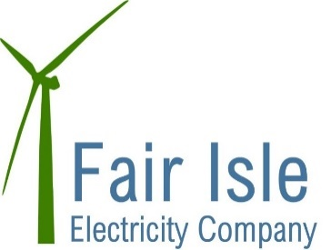
Newsletter - October 2017

Design Development

The planning application for the turbines was submitted to Shetland Island Council in September.

The planning consent for the cable route and buildings stipulated a number of planning conditions. This month we have been working on closing some of these conditions out by submitting scopes to SIC for the Ecological and Archaeological Clerk of Works who are required to monitor the project. We have also submitted a Construction Environmental Management Plan to SIC for approval.

Construction Phase

We have been busy this month evaluating the tenders which were returned from bidders. We received 3 tenders for the combined civils and electrical works for the project and one for the electrical alone. Unfortunately the costs were all much higher than expected and so there has been a process of reviewing what was included in each tender and seeking clarifications. All bidders are comfortable they can meet the project timescales. We hope to be able to announce who has been successful soon and give a definitive start date for the project.

Funding

Because the tender returns were much higher than anticipated there has been a requirement to try and find additional funding. Big Lottery have provided an additional sum and we hope that LCITP will increase their contribution and confirm this in October.

Next Steps

We hope that the contracts for the main works and the turbines will be awarded during the month. This means that you will see work start this year. We will advise you when this is happening and create an opportunity for you to ask questions about how the work will be managed on the island.

How we will keep you updated

A newsletter will be produced every month from now and circulated by FIEC. Copies will also be available in the shop. Copies will also be posted on the Fair Isle Website.

How you can help...........

If you have any questions please in the first instance send them to Robert or any of the Electricity Company Directors who will try and get a response for you.

